Automated CI/CD DevOps Matrices
A Capstone Project Report of MSIT 5910

Submitted by:

Mamdoh Mosad Zeyad (C110312832)

For the partial fulfilment of the requirements for the degree of
Master of Science in Information Technology

Supervised by:
Prof. Thi Thanh Thien Le

Department of CS & MSIT
University of the People, Pasadena, CA 91101, United States
Term 4, April 2026

ABSTRACT
In the landscape of the Software Engineering industry, Continuous Integration and Continuous Deployment (CI/CD) pipelines are considered essential components of modern agile software development. However, when an organization's scales grow rapidly, they suffer from toolchain fragmentation. Data such as build durations, deployment frequencies, and test failure rates become isolated within separate systems like Jenkins, GitHub Actions, and Jira. This fragmentation leads to operational blind spots, forcing the engineering teams into reactive troubleshooting and obscuring actual team velocity. This project addresses these challenges by developing the Automated CI/CD DevOps Metrics Web Application. Using the ASP.NET Core Model-View-Controller (MVC) framework, this on-premises solution centralizes scattered telemetry into a secure Microsoft SQL Server database. Moreover, the system integrates Microsoft ML.NET to perform predictive analytics, utilizing binary classification to proactively identify high-risk deployments before they reach production. This report outlines the project’s literature review, problem definition, and system architecture, while documenting the milestones achieved and the technical challenges mitigated during the initial development phases.

ACKNOWLEDGEMENT
I would like to express my thanks to Prof. Thi Thanh Thien Le for all the support and guidance throughout the MSIT 5910 Capstone Project. I also want to extend my thanks to the University of the People and the Department of Computer Science for providing the academic foundation necessary to execute this enterprise-level software engineering endeavor. I would like to add a special thanks to President Shai Reshef for allowing us to achieve our degree at a high-quality education level.

LIST OF TABLES
Table1. Resources Justification Table 13

LIST OF FIGURES
Figure 1. Plan Gantt Chart 12
Figure 2. System Architecture 18

CONTENTS
Abstract 2
Acknowledgement 3
List of Tables 4
List of Figures 5
1. Introduction & Problem Statement 7
1.1 Project Overview 7
1.2 Problem Context 7
1.3 Identified Stakeholders 8
1.4 Formulated Problem Statement 8
1.5 Project Scope 8
1.6 Assumptions and Limitations 9
1.7 Project Goals 9
1.8 Expected Outcomes 10
1.9 Ethical and Security Implications 10
1.10 Project Planning Tools 12
2. Literature Review 16
2.1 Overview of Related Work 16
2.2 Comparative Analysis of Existing Systems 17
2.3 Research Gap Identification 17
3. System Design 18
3.1 System Architecture 18
3.2 Module-Wise Breakdown 19
3.3 System Requirement Specifications 21
3.4 Version Control and Collaboration 22
4. Documentation of Progress 24
4.1 Milestones Achieved 24
4.2 Challenges Faced and Mitigations 25
5. Conclusion 26
References 27

INTRODUCTION & PROBLEM STATEMENT

1.1 Project Overview
Continuous Integration and Continuous Deployment (CI/CD) are essential for delivering high-quality, enterprise-level applications. However, these deployment toolchains are highly complex, and organizations often suffer from data fragmentation, leading to critical operational gaps. An Automated CI/CD DevOps Metrics MVC Web Application will bridge the gap between isolated deployment systems and integrate Microsoft ML.NET for predictive machine learning analytics. This project aims to provide technical leadership with a centralized, secure, and scalable reporting solution, designed to improve team agility and workflow stability.

1.2 Problem Context
In today's software engineering landscape, Continuous Integration and Continuous Deployment (CI/CD) are the cornerstones of agile development. However, many organizations face significant gaps in their toolchain. Critical data, such as code submission rates, build duration, automated test failure rates, and deployment pace, is confined to separate, isolated systems (e.g., Jenkins, GitHub Actions, and Jira). This fragmentation creates a major operational gap in DevOps. When deployment bottlenecks occur or build consistently fail, engineering teams are forced to troubleshoot reactively and manually access system logs across multiple platforms. This fragmented approach slows down the team, increases downtime, and delays the arrival of critical enterprise applications.

1.3 Identified Stakeholders
- IT Managers and Technical Leads: The lack of central data prevents them from accurately measuring the return on investment (ROI) of development cycles or identifying ongoing bottlenecks in workflows. Solving this problem adds value to the organization by replacing reactive troubleshooting with proactive, data-driven decision-making.
- Software Developers and QA Engineers: Fragmented systems lead to frustrating, time-consuming debugging sessions for pipeline failures, a phenomenon that has been shown to increase employee burnout in enterprise teams significantly (DORA, 2023). Solving this problem directly reduces manual debugging time, alleviates the knowledge burden, and creates a more stable and predictable release path.

1.4 Formulated Problem Statement
Development organizations often lack a centralized, unified tool for collecting, monitoring, and analyzing Continuous Integration and Continuous Deployment (CI/CD) metrics. This fragmentation of tools slows down team workflows, prevents accurate performance reporting, and delays identifying deployment bottlenecks, ultimately weakening software delivery efficiency and overall system stability.

1.5 Project Scope

In-Scope
- Developing an MVC web application to provide an interactive user interface.
- Creating a Microsoft SQL Server database schema to store aggregated telemetry data.
- Integrating Microsoft ML.NET to perform predictive machine learning analytics on build logs.
- The application will be deployed on-premises using Internet Information Services (IIS).

Out-of-Scope
- Cloud deployments (such as Microsoft Azure or AWS) to maintain strict local data governance.
- Modifying the source code of the underlying source control systems or managing external infrastructure.

1.6 Assumptions and Limitations
- It is assumed that the current existing resources can support on-premises local execution of ML.NET models without requiring external hardware accelerators.
- One of the main limitations is the final project timeframe of eight weeks, which limits the amount of historical data that the machine learning model can initially be trained on.

1.7 Project Goals
- Develop and deploy an ASP.NET Core MVC web application that aggregates Continuous Integration/Continuous Delivery (CI/CD) pipeline data and uses native machine learning (ML.NET) to predict build failures.
- Successfully integrate and analyze Webhook data from at least two different deployment tools, and display at least four key DevOps metrics (e.g., deployment frequency, change duration) on the MVC dashboard.
- The project utilizes established enterprise technologies (.NET Core, SQL Server, IIS) that align with my professional experience as a systems administrator and integrated application developer.
- The project directly addresses a specific operational gap by providing technical leadership with a unified and actionable reporting interface.
- The entire software development lifecycle, from database design to IIS deployment, will be completed by the final week (8) of the graduation project schedule.

1.8 Expected Outcomes
The primary tangible outcome of this project will be a fully functional, production-ready ASP.NET Core MVC web application, including the following:
- An interactive web portal (Views).
- Core business logic and data routing (Controllers).
- Database Entities (Models).
- Optimized Microsoft SQL Server database schema.
- Comprehensive technical documentation detailing the application architecture.
- Integrated ML.NET module capable of detecting anomalous build logs directly through the web interface.

1.9 Ethical and Security Implications

Identify Potential Ethical Issues
Implementing a centralized dashboard for metrics raises significant ethical considerations, particularly regarding data privacy and fairness. While the system aims to measure the efficiency of the Continuous Integration/Continuous Delivery (CI/CD) pipeline, the aggregated data inherently tracks the performance and output of individual developers. An ethical risk exists that IT management could misuse these metrics as a punitive monitoring tool rather than a process improvement mechanism. Furthermore, relying on machine learning to predict deployment failures carries the risk of algorithmic bias; if the algorithm mistakenly classifies a developer's modifications as "high risk" based on flawed historical patterns, it could negatively impact their professional standing.

Evaluate Security Implications
As is well-established in project management literature regarding planning, security policing should be implemented early in the information technology lifecycle (Watt, n.d.). Consolidating proprietary source code archives and deployment configurations into a single database is a highly valuable objective for both. Many security attacks involve SQL injection via MVC application entries, cross-site scripting (XSS) in control panel interfaces, and the ability to identify unauthorized access to sensitive member data. While machine learning integration requires a siloed environment, successful DevOps designs with predictive models have been shown to significantly improve the waterline sensing and resilience by identifying anomalies before deployment (Kakolu & Faheem, 2025).

Proposing Mitigation Measures
- Ethical Code of Conduct: The application will be designed to aggregate data at the team or project level rather than the individual level, anonymizing developer IDs to prevent punitive monitoring and ensure the tool is used exclusively for workflow improvement.
- Access Control: A robust Role-Based Access Control (RBAC) system will be implemented within the ASP.NET Core application to ensure that only authorized technical leaders have access to predictive reports.
- Data Security: To mitigate vulnerabilities, the application will use Entity Framework Core to control database queries (preventing SQL injection). All data will be encrypted in transit using HTTPS/TLS protocols enforced by the IIS server, and the ML.NET model will operate in a completely isolated, offline network environment to ensure no data is leaked to external public clouds.

1.10 Project Planning Tools

Gantt Chart
Figure 1
Plan Gantt Chart
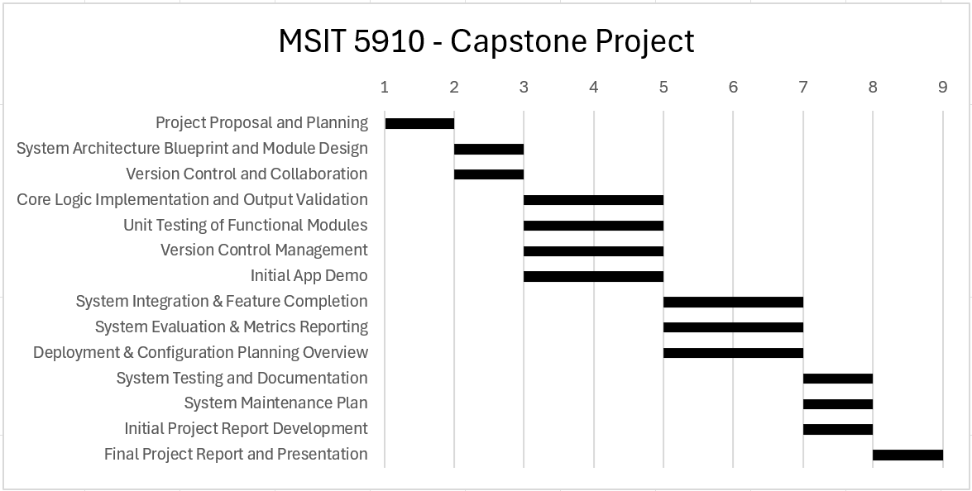

Resource Justification Table
Table 1
Resources Justification Table
Resource | Purpose | Justification
Laptop | Hardware Environment | This is the essential device required to write code, host a local SQL database during development, and run the machine learning models for testing and deployment.
Internet Connection | Research & Dependency Management | An internet connection is required to access journals for literature review, downloading the necessary NuGet packages for ASP.NET Core and ML.NET implementation.
.NET SDK 8.0 | Core Build Tools | A Software Development Kit is required to build, compile, and execute the project programmed by ASP.NET Core MVC. SDK provides us with the required command-line interfaces (CLI) and libraries for the backend architecture.
ASP.NET Core 8 (MVC) | Application Framework | It provides a robust, secure, and structured model (Model-View-Controller) for building enterprise web applications, separating business logic from user interfaces.
Microsoft SQL Server | Relational Database | It provides enterprise-level data storage, high-speed transaction support, and seamless integration with the .NET Entity Framework.
Visual Studio 2022 | IDE | The industry-standard Integrated Development Environment (IDE) for C# development, which provides advanced tools for debugging, scaffolding, and performance profiles.
draw.io | Architecture Modeling | A lightweight, open-source diagramming tool used to create project visuals, including entity-relationship (ER) diagrams for databases and MVC flowcharts.
Microsoft ML.NET | Machine Learning Framework | A native, open-source machine learning framework for .NET developers. It allows for the seamless integration of predictive algorithms (e.g., binary classification for build failures) directly into the C# codebase without requiring external hardware accelerators.
Internet Information Services (IIS) | Web Server Hosting | A secure, scalable, native Windows Server hosting environment ensures strict compliance with the company's firewall.

Feasibility Checklist
To ensure the project's successful completion, a feasibility assessment was conducted across three areas:
- Technical Feasibility: The project is fully based on the Microsoft .NET ecosystem, SQL Server, and IIS. As an integrated developer with extensive experience in system administration and C#, I possess the necessary technical expertise to implement MVC architecture and database integration. Integrating machine learning capabilities via ML.NET is a well-documented process.
- Operational Feasibility: The proposed solution directly addresses a documented pain point for enterprise IT management. By providing a web-based dashboard, stakeholders can access metrics using standard web browsers without needing to install specialized software on their local machines, ensuring high adoption rates.
- Economic Feasibility: The project is highly cost-effective. It utilizes the existing on-premises infrastructure to host IIS and SQL Server databases. Furthermore, by leveraging the open-source machine learning frameworks (ML.NET) and the existing community for Visual Studio and .NET, the project requires no additional financial purchases.

LITERATURE REVIEW
To achieve a high-quality project, academic research and industry standards regarding DevOps must be followed. To support this research, a preliminary review of current literature focusing on remote DevOps measurements and artificial intelligence was conducted, guided by established research methodologies (Sheppard, 2019).

2.1 Overview of Related Work
Recent scholarly literature emphasizes the critical role of continuous delivery while simultaneously highlighting the operational challenges of modern deployment pipelines. A meta-analysis by Miriyala et al. (2025) on CI/CD performance showed that while continuous delivery practices significantly improve deployment speed, organizations face major barriers to operational transparency. The researchers assert that "tool chain fragmentation" and legacy infrastructure prevent teams from accurately measuring speed and maintaining system stability, leading to serious operational gaps in modern software delivery.
A study conducted by Kumar et al. (2025) explored optimizing CI/CD paths using AI-powered build failure prediction. Their research evaluated multiple machine learning models on massive build log datasets, demonstrating that AI can successfully transform CI/CD pipelines from reactive troubleshooting to proactive failure prevention. The biggest challenge in this study was collecting the massive datasets required to train the models.

2.2 Comparative Analysis of Existing Systems
When comparing the existing enterprise CI/CD environments against the theoretical models, an operational gap will appear. Current systems fall into two categories: highly fragmented native tools or cloud-dependent analytics platforms.
On one hand, enterprise companies using CI/CD systems like Jenkins or GitHub Actions are efficient in completing the work, but they work on data silos. These systems fail to provide unified transparency, actively contributing to the toolchain fragmentation identified by Miriyala et al. (2025). On the other hand, emerging platforms offering advanced AI often require exporting massive volumes of proprietary build logs to external cloud environments. As Kumar et al. (2025) noted, the biggest challenge in optimizing CI/CD paths is collecting the massive datasets required to train these models.

2.3 Research Gap Identification
These findings directly support my project's context and highlight a critical gap in current research. While Miriyala et al. (2025) identified the fragmentation problem of the CI/CD toolchain, and Kumar et al. (2025) demonstrated the value of predictive AI in early fault detection, there is a clear lack of practical frameworks linking these concepts. This deficiency lies in the collection of the data necessary for the successful implementation of both processes. Studies have demonstrated a clear gap and a pressing need for a fundamental solution to data collection, leading us to propose a local API solution that collects fragmented data and utilizes local AI models to provide predictive analytics without compromising enterprise security.

SYSTEM DESIGN

3.1 System Architecture
Figure 2
System Architecture
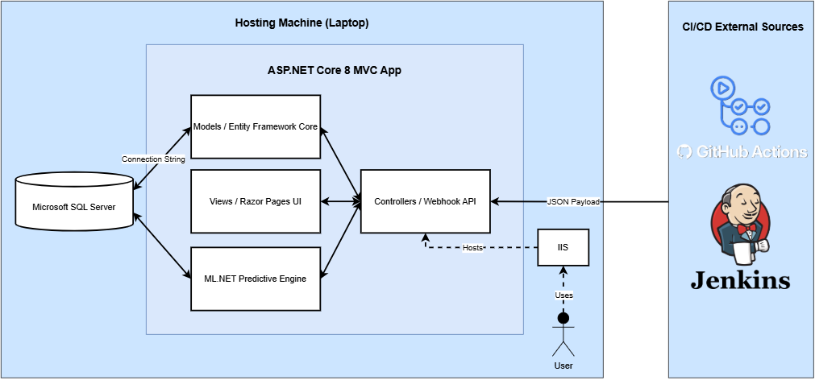
The web application architecture, "Automated CI/CD DevOps Metrics," is based on the MVC (Models-Views-Controllers) architecture and a client-server model. According to Red Hat (n.d.), choosing the right architectural pattern is crucial for determining data flow and gaining a comprehensive understanding of how the project works. The MVC pattern breaks down the web into multiple parts by dividing it into internal data representations (models), data views (views), and the logic that governs system behavior (controllers). When deployed locally via IIS, this design ensures high coherence and low interconnectivity, allowing machine learning and data ingestion layers to operate securely within the enterprise network.

3.2 Module-Wise Breakdown
To effectively manage software engineering problems, the system must be divided into several manageable parts (Summers, 2020). The system will be divided into four core modules:

Module 1: Webhook Intake API (Controllers)
- Input: JSON payloads generated by external CI/CD tools (such as Jenkins and GitHub Actions), including build time details, commit data, and success/failure statuses.
- Output: Structured C# objects bound to system memory.
- Methodology: Because different deployment platforms structure their webhook payloads uniquely, the Webhook Intake API employs a dedicated parser abstraction pattern. For instance, a Jenkins payload might nest the build status under a build.phase node, whereas GitHub Actions utilizes a workflow_run.conclusion schema. The API standardizes these disparate JSON objects into a unified DeploymentRecord Data Transfer Object (DTO). This DTO includes normalized fields such as a universal timestamp, a standardized repository identifier, the author's anonymized ID, and a Boolean success flag. This normalization layer is critical; without it, the downstream SQL Server database and ML.NET engine would be unable to process the data uniformly, which would severely degrade the accuracy of the predictive analytics.

Module 2: Data Continuity Layer (Models)
- Input: Structured C# objects containing pipeline metrics.
- Output: Relational records securely committed in Microsoft SQL Server.
- Methodology: Entity Framework (EF) Core is used as the interface between objects and relational databases (ORMs). EF Core translates C# models into an SQL schema, ensuring data integrity and protecting against SQL injection attacks via flagged queries.

Module 3: Predictive Analytics Engine (ML.NET)
- Input: Historical CI/CD build logs and real-time incoming pipeline data.
- Output: A binary classification prediction (logical: probability of failure/probability of success) accompanied by a confidence level.
- Methodology: Specifically, the FastTree binary classification algorithm utilizes a gradient boosting implementation based on decision trees. In the context of CI/CD telemetry, the algorithm constructs an ensemble of trees where each subsequent tree corrects the predictive errors of the prior tree. The model evaluates critical features such as build_duration_seconds, lines_of_code_changed, and test_coverage_percentage. To prevent overfitting on historical data, the training pipeline incorporates k-fold cross-validation. This ensures that the model's confidence scores accurately reflect the probability of a deployment failure, allowing technical leads to configure custom threshold alerts (e.g., triggering a manual review if the failure probability exceeds 75%).

Module 4: Display Layer and Dashboard (Views)
- Input: Collected telemetry data and user-requested ML.NET predictions.
- Output: Interactive HTML/CSS user interfaces displaying graphs, speed indicators, and risk alerts.
- Methodology: This module was developed using ASP.NET Core Razor pages, which securely connect backend data to visible frontend templates, providing technical leadership with a unified reporting dashboard.

3.3 System Requirement Specifications

Functional Requirements (FRs)
- The system must expose secure API endpoints capable of receiving and parsing JSON webhooks from external CI/CD sources.
- The system must store all pipeline telemetry into a centralized SQL server database.
- The system must execute a local ML.NET model to analyze incoming deployment data and flag high-risk builds.
- The system must display visual dashboards for app users, showing DevOps metrics (e.g., deployment frequency, lead time).
- The system must provide a secure authentication portal for users to log in before accessing the dashboard or predictive metrics.
- The system must provide administrative features that allow team leads to add new CI/CD webhook sources and map them to specific internal teams.

Non-Functional Requirements (FRs)
- The system must restrict dashboard access using Role-Based Access Control (RBAC) and process all data on-premises (no external cloud APIs) to protect proprietary deployment configurations.
- The dashboard views must load and render data within 2.0 seconds under normal behavior.
- The application must maintain 99.9% uptime during standard business hours.
- The application must maintain up to 100 concurrent users without any failure.
- The API must handle the processing of 50 concurrent JSON payloads per second without data loss.
- The application must have an internal log that records all failed authentication attempts, API parsing errors, and ML.NET execution failures for troubleshooting.

3.4 Version Control and Collaboration
A Git-based version control system has been established to manage the project lifecycle.
- Repository URL: https://github.com/Mamdoh-Zeyad/MSIT-5910-CAPSTONE-PROJECT.git (Note: The repository is set to public for now, and it will be changed for the upcoming weeks).
- Folder Structure: The repository is organized with different folders to separate concerns:
  - /src: Contains the primary folders for the ASP.NET Core source code.
  - /assets: Contains all the folders for saving the assets for documentation (e.g., specifications, literature review, and academic research).
  - /flows: Contains all diagrams related to the project (e.g., Architecture Diagram, ER Diagram, …).

Overview of Branching Approach and Traceability
Effective collaborative software development relies heavily on version control to prevent developers from overwriting each other's work (Davies, 2024). In this capstone project, I implemented a structured fork strategy in Git, heavily inspired by the Git Flow methodology.
The repository has two permanent branches: main and development. The main branch is dedicated exclusively to production-ready software; direct modifications to it are prohibited. The development branch serves as the core integration environment where tested features are integrated.
When working on a new module, such as the ML.NET Prediction Engine, I create a dedicated feature branch from the development branch (e.g., feature/mlnet-integration). This ensures that the underlying codebase remains clean and efficient, while experimental or complex changes are securely isolated (Davies, 2024). Once the feature is complete, it is integrated back into the development branch using a pull request.
The version control system inherently ensures consistent documentation and traceability of changes. By adhering to a strict commit message convention (such as using prefixes like feat: add webhook controller or fix: fix SQL connection timeout issue), the Git log becomes a stable and readable record of the software development lifecycle. If a critical error occurs while integrating ASP.NET interfaces, the Git log allows me to precisely track when and where the error occurred, and the `git revert` command enables me to smoothly revert to a stable state without losing operational momentum. This systematic approach ensures that both the source code and the associated design documentation are developed concurrently and securely.

DOCUMENTATION OF PROGRESS

4.1 Milestones Achieved
- Project Proposal: I successfully established the project boundaries, identified stakeholders, set the project scope, and defined the goals of the project. A comprehensive literature review was conducted on different scholars focusing on remote DevOps and integrating AI with DevOps. Moreover, I identified the gaps in the current research, and I proposed solutions to fix them.
- Project Planning: I set a good plan by analyzing the requirements for each week throughout the entire term, and I set my Gantt Chart. Moreover, I created a table to list all the resources needed before starting the project. Lastly, by setting a feasibility checklist, I can ensure that I am on the right track to complete the project by achieving its goals.
- System Architecture Blueprint and Module Design: Completed the system design phase, establishing the architecture of the system and setting the architecture diagram. In addition, data flows are explained from external DevOps sources to the local SQL server. I set the functional and non-functional requirements of the system to achieve a high-quality operational system.
- Version Control and Collaboration: I set up a repository in GitHub to hold all the work done through the project phases. The repository has a proper structure (/src, /assets, /flows). Moreover, I set Git branching strategy (main, development, development-feature) to ensure a stable foundation for code integration.

4.2 Challenges Faced and Mitigations
- Hardware Resources Constraints: Initially, the project was proposed to use local Large Language Models (LLMs) via Ollama to analyze build logs. However, after inspecting my resource (Laptop) specs, I found out that 8GB of RAM is not enough to run these large models, Visual Studio, SQL Server, and IIS simultaneously without causing severe system paging and crashes.
  - Mitigation: After extensive searching, I found that using Microsoft ML.NET instead of LLMs is better, with 8GB of RAM. ML.NET is a highly efficient, native .NET machine learning framework. By shifting the predictive strategy to a binary classification model analyzing tabular data, the project maintained its innovative AI requirement while dramatically reducing hardware overhead and ensuring stable application performance.
- Time Constraints: Starting from the first week, as A Software Engineer in Aquat company, I found some challenges managing the time between the job and the capstone project, which caused me some headaches and added more pressure on me.
  - Mitigation: I divided my day into sections and removed any unnecessary tasks of the day using a strict plan for my day and life. Having a good sleep is the secret to accomplishing my goal.

CONCLUSION
The Automated CI/CD DevOps Metrics Web Application presents a secure solution to the pervasive challenge of toolchain fragmentation that is currently affecting the enterprise software development industry. As outlined throughout this report, reliance on multiple external deployment systems obscures actual team performance and forces engineering departments into inefficient, reactive troubleshooting cycles. Thus, going through the phases of this capstone project from initial problem conceptualization to a rigorous architectural blueprint, a clear pathway has been established to resolve these operational blind spots.
The proposed architecture effectively aggregates the deployment data into a unified, on-premises Microsoft SQL Server database, presented through an intuitive ASP.NET Core MVC interface. This design will ensure data governance and security, entirely bypassing the vulnerabilities associated with external cloud dependencies. Furthermore, the integration of ML.NET will turn the system into a proactive, predictive asset. By utilizing binary classification algorithms to analyse historical pipeline data, the system empowers technical leadership to intercept high-risk builds before they impact production environments.
Ethical integrity and security-by-design are foundational to this system. RBAC data sanitization and data minimization ensure developers are supported with objective metrics rather than punitive surveillance. As the project transitions to active coding, our version control and modular framework guarantee the successful delivery of a tool that optimizes the software delivery lifecycle.

REFERENCES
Davies, S. (2024). Blueprints: Creating, describing, and implementing designs for larger-scale
software projects (Version 2.5). University of Mary Washington.
DORA. (2023). Accelerate state of DevOps report 2023. Google Cloud.
https://services.google.com/fh/files/misc/2023_final_report_sodr.pdf
Kakolu, S., & Faheem, M. A. (2025). AI-driven DevOps automation: Enhancing CI/CD
pipelines. Iconic Research and Engineering Journals, 8(1).
https://www.researchgate.net/publication/388780599_AI-Driven_DevOps_Automation_Enhancing_CICD_Pipelines
Kumar, R., Kollipara, D. N. D., Mohammed, A. H., Kumar, S., Mohammed, F. B., & Kumar, A.
(2025). Optimizing CI/CD pipelines with AI-driven build failure prediction: An empirical study on machine learning models for early failure detection. Spectrum of Engineering Sciences, 3(10). https://thesesjournal.com/index.php/1/article/view/1509
Miriyala, N. S., Bandaru, B. K., Mittal, P., & Rai, A. (2025). Redefining speed and
stability: A meta-analysis of CI/CD performance through DORA metrics. Digitus: Journal of Computer Science Applications, 3(1), 42-52.
https://journal.idscipub.com/index.php/digitus/article/view/952
Red Hat. (n.d.). 14 software architecture patterns.
https://www.redhat.com/en/blog/14-softwarearchitecture-patterns
Sheppard, V. A. (2019). An introduction to research methods in sociology. Justice
Institute of British Columbia. https://pressbooks.bccampus.ca/researchmethods/
Summers, B. (2020). Effective methods for software engineering. Auerbach Publishers.
Watt, A. (n.d.). Project management (2nd ed.). BCcampus.
https://pressbooks.ulib.csuohio.edu/projectmanagement2ndedition/

